NTARF# <<NTARF #>> s. 2026
[NON-TRAVEL] ACTIVITY REQUEST FORM

Name of Requester |  | <<Name of Requester>> (<<College/Office/Project>>)
Date Filed |  | <<Timestamp>>
Activity Requested |  | <<Activity Requested>>
Main Organizer |  | <<Main Organizer>>
Justification/Explanation |  | <<Justification/Explanation>>
Venue |  | <<Venue>>
Date & Time of Activity |  | <<Date of Activity>> TO <<Date of Activity End>>  (<<Time of Activity Start>> TO <<Time of Activity End>>)
Involved WPU Personnel |  | <<Involved WPU Personnel (Position)>>
Type of Involvement |  | <<Type of Involvement>>
Requested Support |  | <<Requested Support (Check all that apply)>>
Funding Charged to |  | <<Funding Charged to>>, <<Funding Specifier>>
Total Estimated Amount |  | <<Total Estimated Amount>>
Status and Notes |  | <<Final Approval>>  <<Notes from Approver or Endorser>>  <<Notes re Fund Availability>>  <<Venue or PMES Notes>>

Recommending Approval:
(Endorsed through NTARF System)  <<Applicable Endorser's Name>> | (Endorsed through NTARF System)  <<Fund Availability Certified By>> | (Endorsed through NTARF System)  <<Endorser for Venue Availability>> | (Endorsed through NTARF System)  <<Endorser for Electricity and Generator Use>>
Immediate Supervisor | Budget/Accounting | Facility In-Charge | PMES Supervisor

Approved:
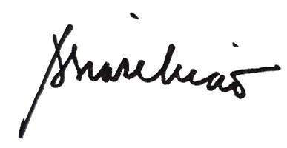

Amabel S. Liao, PhD
University President

OFFICE ORDER FOR NON-TRAVEL ACTIVITIES

No. <<NTARF #>>, s. 2026

TO: <<Involved WPU Personnel (Position)>>

You are hereby <<Final Approval>> to be involved in the <<Activity Requested>> on <<Date of Activity>> TO <<Date of Activity End>> (<<Time of Activity Start>> - <<Time of Activity End>>) as <<Type of Involvement>>.

Please be guided accordingly.



Amabel S. Liao, PhD
University President

